**Priority**

import java.util.*; class Process { int processId; int arrivalTime; int burstTime; int priority; int CT;

int waitingTime; int turnaroundTime;

Process(int processId, int arrivalTime, int burstTime, int priority) { this.processId = processId; this.arrivalTime = arrivalTime; this.burstTime = burstTime;

this.priority = priority; this.waitingTime = 0; this.turnaroundTime = 0; this.CT = 0;

}

}

class priority { public static void main(String[] args) {

Scanner scanner = new Scanner(System.in);

System.out.print("Enter the number of processes: "); int numProcesses = scanner.nextInt();

List<Process> processes = new ArrayList<>();

for (int i = 0; i < numProcesses; i++) {

System.out.print("Enter the Arrival Time for process "+(i+1)+": "); int arrivalTime = scanner.nextInt();

System.out.print("Enter the Burst Time for process "+(i+1)+": "); int burstTime = scanner.nextInt();

System.out.print("Enter the Priority for process "+(i+1)+": "); int priority = scanner.nextInt(); System.out.println(); processes.add(new Process(i + 1, arrivalTime, burstTime, priority));

}

// Sort the processes by priority

Collections.sort(processes, Comparator.comparingInt(p -> p.arrivalTime));

int currentTime = 0; float totalWaitingTime = 0; float totalTurnaroundTime = 0;

System.out.println("Pid\tAT\tBT\tPT\tCT\tWT\tTAT");

for (Process process : processes)

{

if (process.arrivalTime > currentTime) { currentTime = process.arrivalTime;

}

process.waitingTime = currentTime - process.arrivalTime; process.turnaroundTime = process.waitingTime + process.burstTime; process.CT=currentTime+process.burstTime; currentTime += process.burstTime;

totalWaitingTime += process.waitingTime;

totalTurnaroundTime += process.turnaroundTime;

System.out.println(process.processId + "\t" + process.arrivalTime + "\t" + process.burstTime +

"\t" + process.priority + "\t"+process.CT +"\t"+ process.waitingTime + "\t" + process.turnaroundTime);

}

float averageWaitingTime = totalWaitingTime / numProcesses; float averageTurnaroundTime = totalTurnaroundTime / numProcesses;

System.out.println("\nAverage Waiting Time: " + averageWaitingTime);

System.out.println("Average Turnaround Time: " + averageTurnaroundTime);

}

}

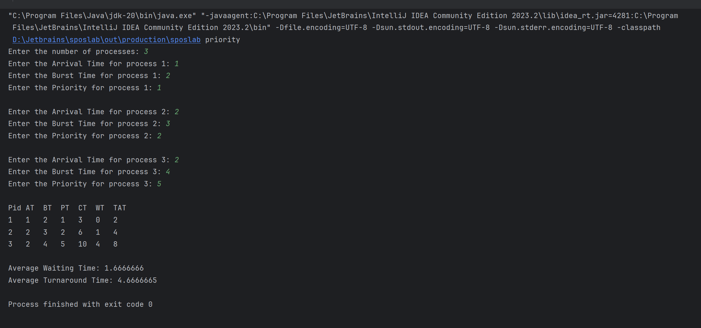**Output:**